Lab - Explore DevNet Resources

# Objectives

**Part 1: Find and Navigate a Learning Lab**

**Part 2: Explore More Resources**

# Background / Scenario

DevNet hosts many resources for developers. As a developer, you will need to understand what is available and what offerings are useful for the platform for which you will develop. You must be familiar with what is available on the site and how to find what you need to begin developing.

In this lab, you will tour the DevNet site to ensure that you know how to get around and find what you need.

If you have not yet created a DevNet account, go to developer.cisco.com, click **SIGN UP FREE** at the top and follow the instructions.

# Required Resources

* 1 PC with operating system of your choice
* Internet access
* Active DevNet Account

**Note**: Although you can use your **DEVASC VM** to complete this lab, it is not required.

# Instructions

## Find and Navigate a Learning Lab

In this part you navigate to an introductory lab in DevNet to learn how to get around the site to find what you are interested in.

* + - 1. Go to developer.cisco.com and log in. All of the learning tools can be found here such as **Learning Tracks**, **Video course**, **Code Exchange**, among others.

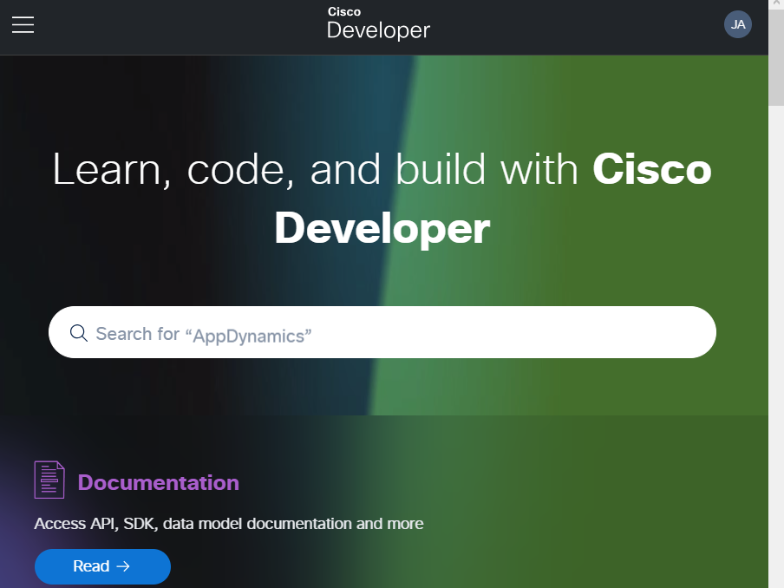

**Figure 1.1 Accessing the link developer.cisco.com.**

* + - 1. Click **Learning Tracks**.

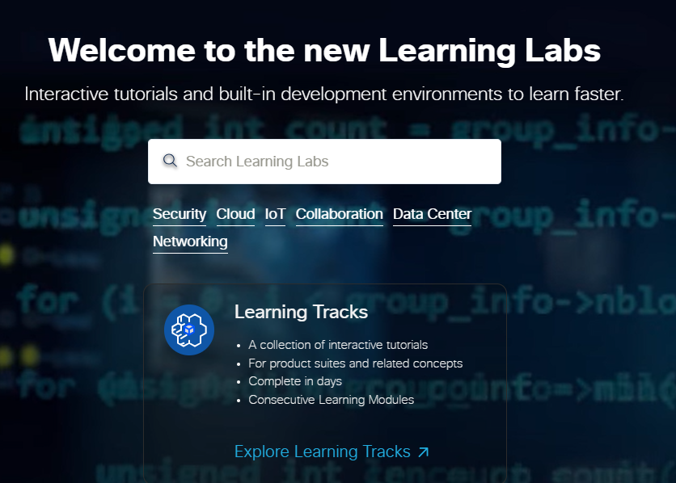

**Figure 1.2 Accessing the learning tracks.**

* + - 1. A new browser tab opens to show you all of the **DevNet Tracks** that you can explore. For this example, scroll down and click **Introduction to DevNet**. This is a beginner's track which covers some fundamentals such as Python coding and network programmability. These skills will be necessary for success in this course. This is a great place to start.
      2. This first module is **Overview & DevNet Resources Beginner** module. It has two reading labs that provide you a quick overview of DevNet. Click the **Overview of DevNet** link to begin the first lab reading lab.
      3. Navigate to and read each page of the **Overview of DevNet** lab.
      4. When done, click the arrow at the bottom of the last page to return to the **Introduction to DevNet** track.

**Note**: Continue working through **Introduction to DevNet** track if you like. However, the rest of the labs in this track assume you have followed DevNet’s procedures for “How To Setup Your Own Computer”. In addition, the content in the **Introduction to DevNet** track is beyond the scope of this module. You will learn more about Git and using Python to make API requests later in the course.

## Explore More Resources

In this part, you spend some time looking through all the available resources at developer.cisco.com.

### Explore the Start Now page.

The DevNet home page has many different ways to find content. As a beginner, the Start Now link is a great way to get started.

* + - 1. From the DevNet home page, click **Start Now**.

This part of the site links you to entry level content in small chunks based on a common technology area.

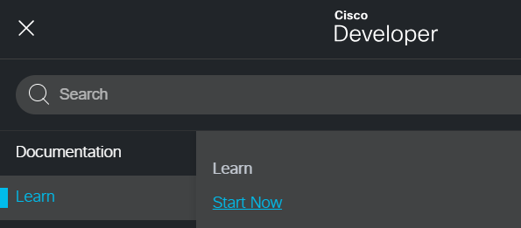

**Figure 2.1 Accessing the start now.**

* + - 1. Click **Networking 101**.

This is a combination of labs that teaches the fundamentals of networking.

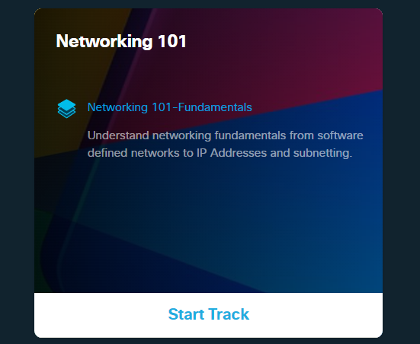

**Figure 2.2 Accessing the Networking 101.**

#### Questions

How many labs are linked on this page?

***3 labs***

What is the total length of the labs?

***2hrs***

* + - 1. Return to the DevNet home page.

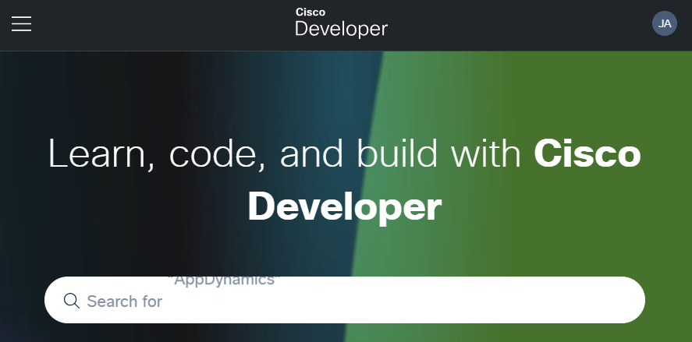

**Figure 2.3 Returning to home page.**

### Explore the Video course page.

Many people prefer to use videos as a primary way to learn. Videos can also help to reinforce the content learned in other ways. They are also a great way to learn on mobile devices when on the go.

* + - 1. From the DevNet home page, click **Video course**.

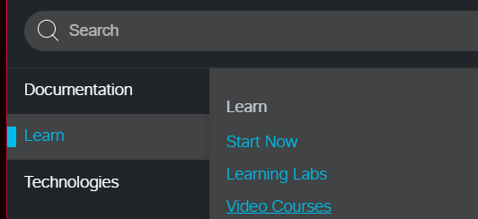

**Figure 2.4 Accessing the video course.**

You can sample any of the modules by clicking any of the videos. You can also play the entire module, or jump to any video of your choice.

#### Questions

How many modules are available as video-based?

***6 modules***

How many videos are available in the Network Device APIs module?

***5 videos are available***

* + - 1. Return to the DevNet home page.



**Figure 2.5 Returning to home page.**

### Explore the Sandbox page.

One of the greatest things about DevNet is the Sandbox. This is a place where you can run your code against real equipment! There are virtualized environments, simulators, and real hardware available for free! Some labs are always running while others require a reservation.

* + - 1. From the DevNet home page, click **Sandbox**.

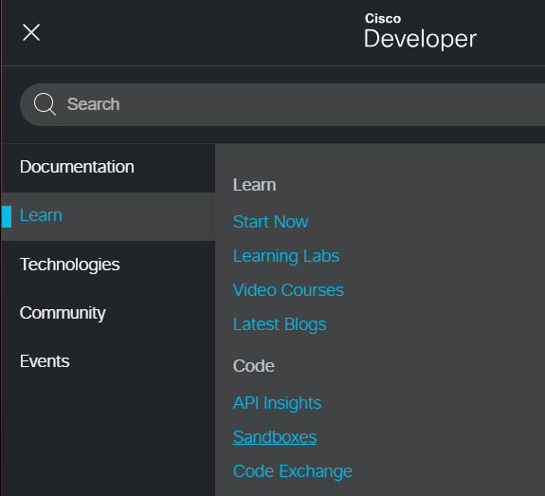

**Figure 2.6 Accessing the Sandbox.**

* + - 1. Click **Learn More**. A new tab will open with an overview of the Sandbox.

#### Questions

Which type of Sandbox provides private access to packaged labs?

***Reservatio Sandboxes***

Where can you go for help if you have difficulty or wish to ask a question about the Sandboxes?

***DevNet Sandbox community forum***

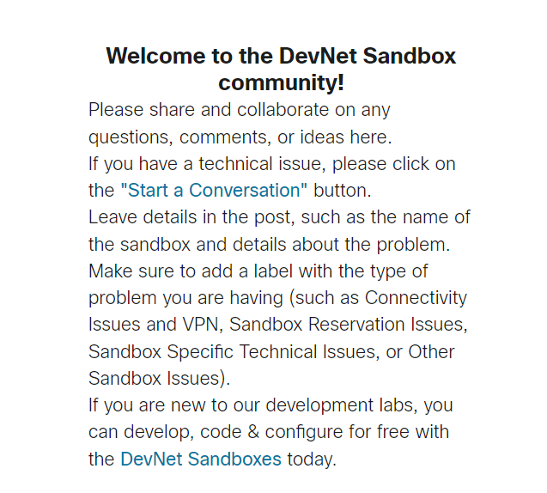

**Figure 2.7 Showing the DevNet Sandbox community.**

* + - 1. Close this tab and return to the DevNet **Sandbox** tab.

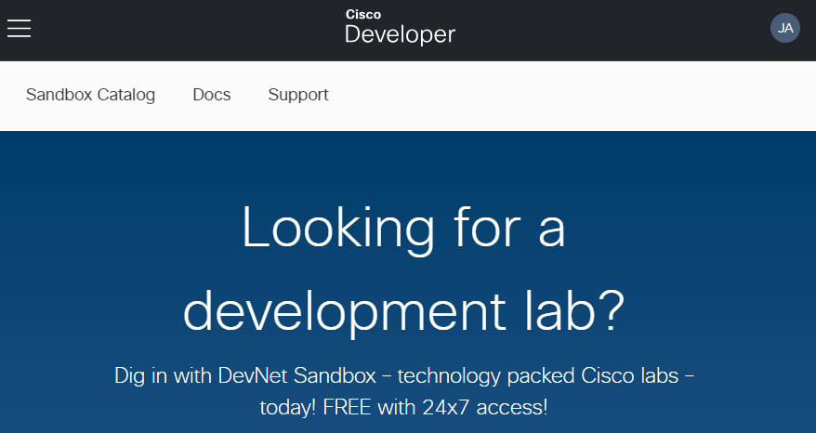

**Figure 2.8 Returning to the Devnet Sandbox tab.**

* + - 1. The Sandboxes are grouped by technology type. Click **Data Center**. A new tab will open with some featured Sandboxes. Notice that the Sandbox Catalog can be found on the left of the page. This allows you to open any of the other Sandbox technology type.

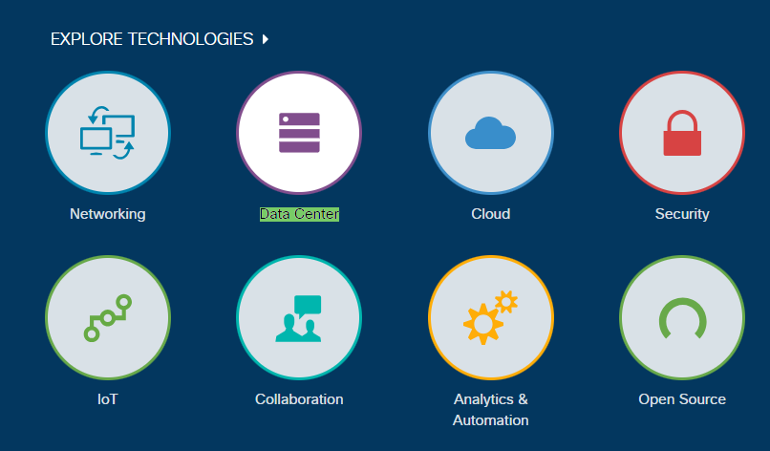

**Figure 2.9 Accessing the Data Center.**

* + - 1. Click **ACI Simulator** on the right side. A new tab will open with the details about the lab, known as the **Blueprint**.

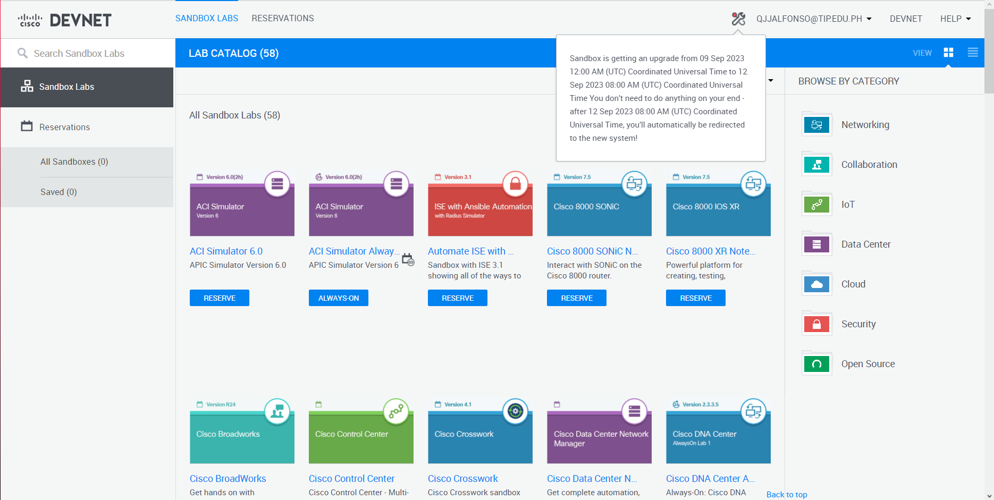

**Figure 2.10 Accessing the ACI Simulator.**

The center of the page shows the topology of the lab if there is one. The right side of the page shows the resource structure of the lab if there are any additional resources in the lab. The overview or instructions for the lab are on the left side of the page. There are also details about how to connect to the ACI server.

#### Questions

What is the url to connect to the ACI server to start the lab?

***https://sandboxapicdc.cisco.com/***

Why is it important not to upload very large resources to the lab?

***You have the option to deplete capacity from other users who are also sharing the lab.***

* + - 1. Close the **ACI Simulator Sandbox Lab** tab. Close the **Data Center** catalog tab.
      2. When you would like to begin your first Sandbox on your own time, you can scroll down to around the middle of the **Sandbox** page and click **Begin Hello World!**. This tutorial will walk you through getting set up and connected. For now, return to the DevNet home page.

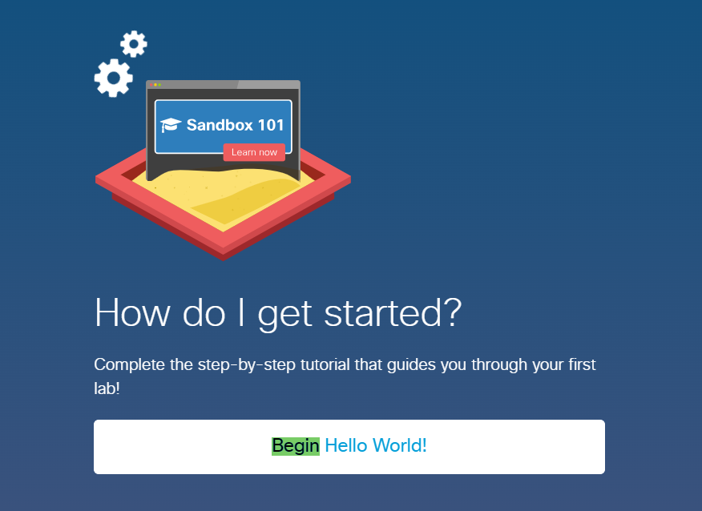

**Figure 2.11 Accessing the Begin Hello World!.**

### Explore the Code Exchange page.

The **Code Exchange** page allows you to work with all kinds of code related to Cisco technologies. These are GitHub projects that help you build and collaborate on projects. You can search for a specific repository or browse by technology.

* + - 1. From the DevNet home page, click **Code Exchange**

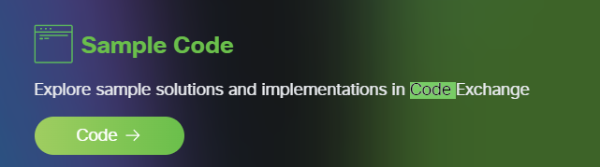

**Figure 2.12 Accessing the Code Exchange.**

* + - 1. Click **Explore repos**.

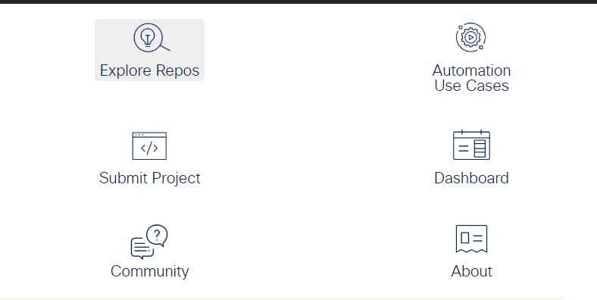

**Figure 2.13 Accessing the Explore repos.**

* + - 1. Choose the **Cisco Webex** category.

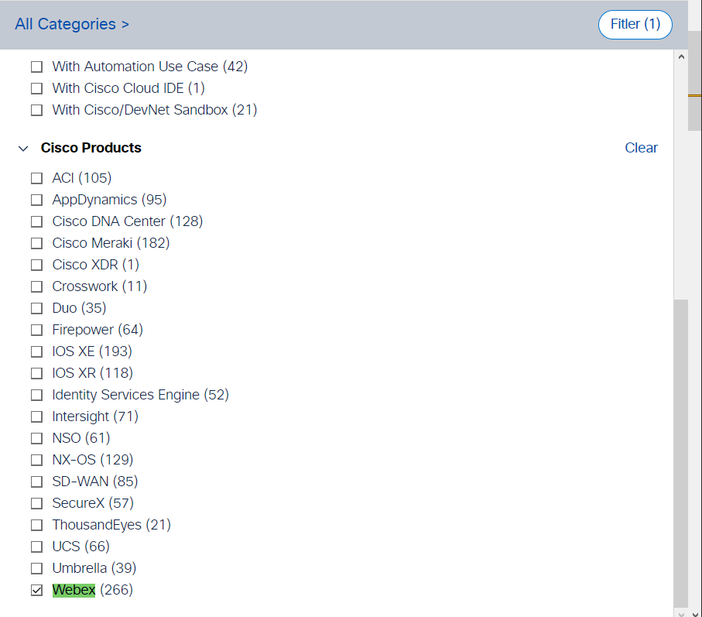

**Figure 2.14 Choosing the Cisco Webex category.**

* + - 1. Choose any repo.

This page tells you all about the project including how to install it, how to use it, and how to download the repository. The link to the GitHub location will tell you much more about the project and show the contents of the different branches.

#### Questions

What is the name of the project?

***awesome-webex***

What category(-ies) does the project fall under?

***Collaboration, Cloud Collaboration, Endpoints, Mobility and Open Source.***

What support options does this project provide?

***The project provides support for Java, JavaScript, Perl, PHP, and Python.***

* + - 1. Return to the DevNet home page.

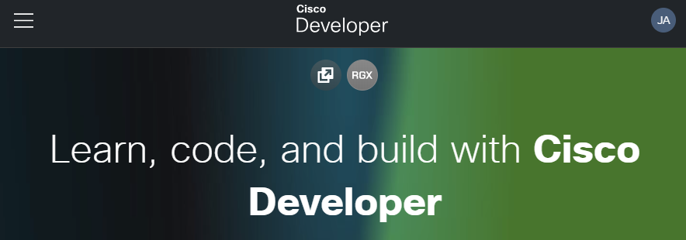

**Figure 2.15 Returning to DevNet home page.**

### Explore the Ecosystem Exchange page.

DevNet is much more than Cisco technologies alone. The Ecosystem Exchange connects the ecosystem of Cisco partners to provide you an aggregation of the solutions built by Cisco partners based on Cisco platforms. You can search for a specific listing or browse by technology areas.

* + - 1. From the DevNet home page, click **Ecosystem Exchange**.
      2. Scroll down and click **Mobility**.
      3. Click any solution listing.

The page will provide you with a description of the solution, and a way to find more information such as requesting information, a website, or even support.

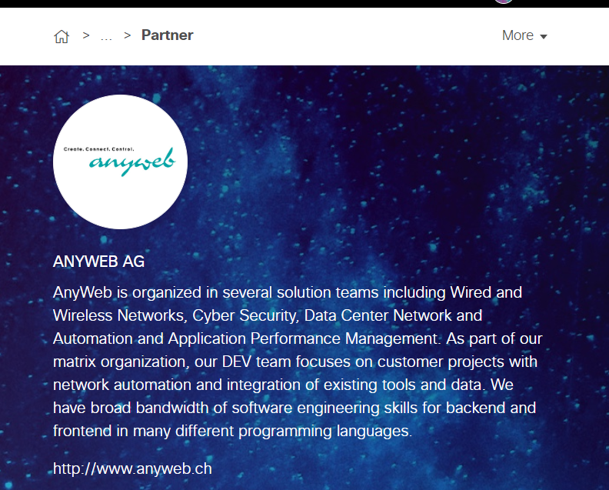

**Figure 2.16 Choosing solution ANYWEB AG.**

#### Questions

What is the partner solution?

***Wired and wireless networks, cyber security, data center network automation, and application***

***Performance management is the focus area of the partner solution.***

What are two ways to get more information about the solution?

***Their LinkedIn and Facebook Profiles.***

* + - 1. Return to the DevNet home page.



**Figure 2.17 Returning to DevNet home page.**

### Explore DevNet platforms.

DevNet organizes even more information around different platforms.

* + - 1. From the DevNet home page, click any category of platforms you are interested in.
      2. Click any platform you are interested in and explore the page.

#### Questions

Which category did you choose?

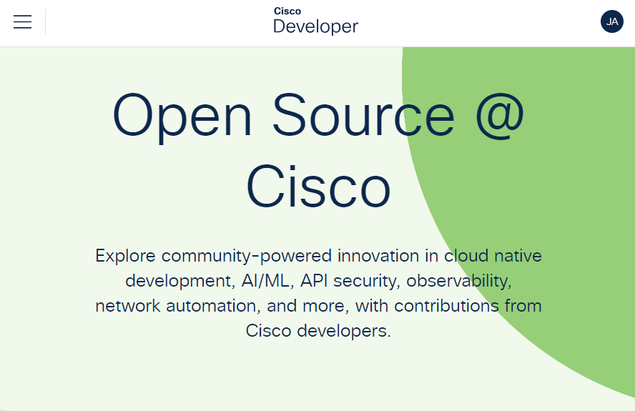

**Figure 2.18 Choosing category open source @cisco.**

***open source.***

What platform did you explore?

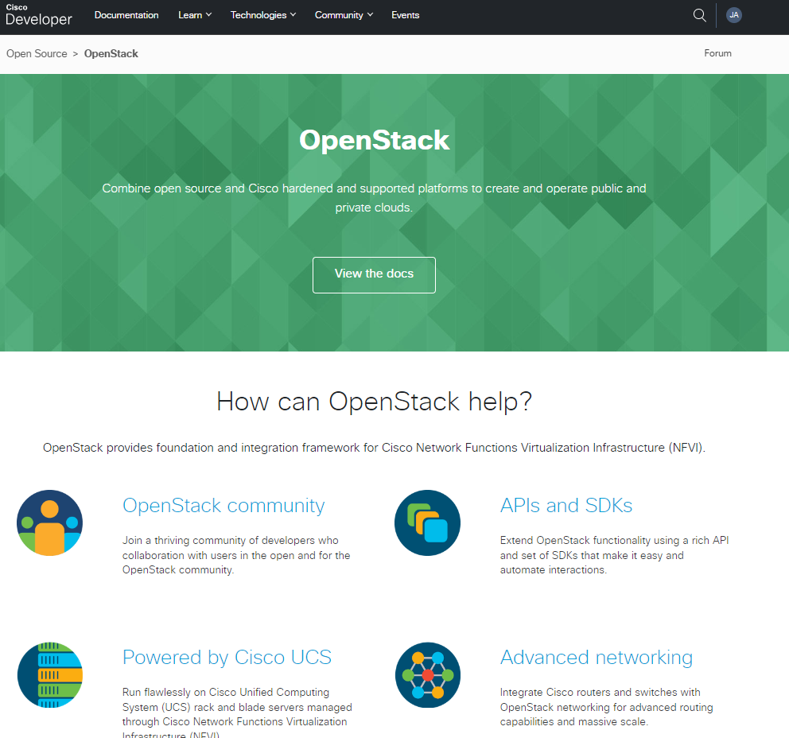

**Figure 2.19 Choosing platform openstack.**

***OpenStack and Contiv.***

**To conclude this hands-on activity, it is clear that navigating the DevNet site is crucial for developers. Understanding the available resources and offerings is essential for efficient platform development. By exploring the DevNet site and creating an account if necessary, you have taken the first step towards becoming familiar with the platform's features and resources. This will surely benefit from this expertise as it will make it easier for you to obtain the resources and knowledge required for success in your development projects.**

*End of document*